Summer Training Report

Submitted in partial fulfillment for the award of Degree of

BACHELOR OF TECHNOLOGY

In

Computer Science & Engineering

**Project Title**

E-Pulse Line

Under Provision of

Er. **Rohit Kumar** (Project Manager)

From

**Training Organization**

Softpro India Computer Technologies (P) Ltd.

Lucknow (UP)

From 10th June, 2019 To 25th July, 2019

Submitted by:

Nadeem Ahmad Ansari

Roll No. : 1601012123

.

Department Of Computer Science & Engineering

Integral University, Lucknow

June, 2019

**Acknowledgement**

I would like to express my deep and sincere gratitude to my supervisor Er. **Rohit Kumar (**Softpro India Computer Technologies (P) Ltd.)***,*** who gave me his full support and encouraged me to work in an innovative and challenging project for Educational field. His wide knowledge and logical thinking gave me right direction all the time.

I am deeply grateful my project coordinator for Ms. **Shivani** help and support provided at every step of the project. Last but not the least, I thank to all employees of **Softpro India Computer Technologies (P) Ltd.** for their support and co-operation.

***Nadeem Ahmad Ansari***

**Student Name**

SOFTPRO INDIA



COMPUTER TECHNOLOGIES PVT.LTD.

(AN ISO 9001:2015 CERTIFIED COMPANY)

**SPI/ST/2019/0087**

**Completion Certificate**

This is to certify that Mr. **Nadeem Ahmad Ansari** of **B.Tech (CSE)** from **Integral University** was working on the project entitled “**E-Pulse Line**” in Softpro India Computer Technologies Pvt. Ltd. He was engaged with us during **10 June** to **25 July** for a period of **45 days.**

He has done an excellent job during his engagement with the Software Development & Testing Division of the company. He has completed his project during the training tenure. His performance has been good and satisfactory.

I would like to take this opportunity to express my appreciation to Mr. **Nadeem Ahmad Ansari** for his work and wish him all the very best for his future endeavors.

**Regards,**

**Ms. Yashi Asthana**

**CEO**

**Softpro India Computer Technologies Pvt. Ltd.**

**Lucknow (U.P.)**

**DECLARATION**

This is to certify that the project report entitled “**E-Pulse Line**” is done by me is an authentic work carried out for the partial fulfillment of the requirements for the award of the B.Tech in **“(Computer Science and Engineering)”** under the guidance of Er**. Rohit Kumar**. The matter embodied in this project work has not been submitted earlier for award of any degree or diploma to the best of my knowledge and belief.

***Nadeem Ahmad Ansari***

**Student Name**

**TABLE OF CONTENTS**

1. **Introduction………………………………………………………………………**
   1. **Overview of Organization**
   2. **Chronological Training Diary**
   3. **Objectives**
   4. **Abstract**
2. **Requirement Analysis…………………………………………………………….**
   1. **Software Requirement Specification**
   2. **Hardware Requirement**
   3. **Software Requirement**
   4. **Details About Technology**
3. **Problem Identification and Feasibility Study………………………………….**
   1. **Economic Feasibility**
   2. **Technical Feasibility**
   3. **Behavioral Feasibility**
4. **Project Description……………………………………………………………….**
   1. **Modules**
   2. **Patient Side Functionality**
   3. **Doctor Side Functionality**
   4. **Admin Side Functionality**
5. **Design……………………………………………………………………………..**
   1. **Context Diagram**
   2. **Data Flow Diagram**
   3. **ER-Diagram**
   4. **Flowchart**
   5. **Snapshots of the Project**
   6. **Database and Tables**
6. **Testing……………………………………………………………………………..**
7. **Future Scope………………………………………………………………………**
8. **Conclusion…………………………………………………………………………**
9. **References…………………………………………………………………………..**

**INTRODUCTION**

The proposed project is a smart appointment booking system that provides patients or any user to booking a doctor’s appointment online in an easy way. This is a web-based application that overcomes the issue of managing and booking appointments according to user’s choice or demands. The task sometimes becomes very tedious for the compounder or doctor himself in manually allotting appointments for the users as per their availability. Hence this project offers an effective solution where users can view various booking slots available and select the preferred date and time. This system also allows users to cancel their booking anytime. The application uses PHP as a front-end and MYSQL database as the back-end.

**Overview of Organization**

Softpro India Computer Technologies (P) Limited, **an ISO 9001:2015 Certified Company**, endowed in 2004 by Technocrats from IIT Kanpur & IET Lucknow. "Softpro Learning Center", A Unit of Softpro India Computer Technologies (P) Limited, commenced in 2008 with a vision to Bridge the Technology Gap prevalent between IT students and IT professionals. SLC has embarked itself as one of the most propitious center for learning across UP and nearby states. The fundamental goal behind the learning center is to reinforce student’s practical skills. Training at SLC helps students to acquire better analytical as well as practical approach.

Knowing the importance of summer training and industrial training in the curriculum, we tailor our training programs in such a way that enrich the students with practical know how and conceptual learning. It includes promulgating Summer Training to B.Tech and Diploma students, Industrial Training to MCA/BCA students and Apprenticeship Program to pass out students of B.Tech/BCA/MCA/Diploma.

Softpro Learning Center increases its profundity in technologies like .Net, Java, PHP, Android and Python and also provides the opportunity to practically implement their theoretical knowledge.

**SLC** offers different types of training & programs like:

* Industrial Training
* Summer Training
* Vocational Training
* Apprenticeship Program
* Faculty Development Program
* In Campus Training Program

The Trainings we offer are extensive in nature & approach which allows the learner to put into practice what he or she has learned and ultimately utilizing it in practical aspects. These trainings are beneficial for conceptual understanding and also provide exposure of IT Industry.

**CHRONOLOGICAL TRAINING DIARY**

* Week 1: HTML
* Week 2: CSS, JavaScript, Database
* Week 3: PHP
* Week 4: PHP, SQL Database
* Week 5: Project Work
* Week 6: Project Work

**OBJECTIVES**

We used a combination of surveys, focus groups, and one-on-one interviews to gather information from patients, doctor, and from key personnel at other medical students. After gathering requirements, we have decided the following aims and objectives of E-Pulse Line portal.

1) To provide anytime/ Anywhere Online Registration.

2) All information /knowledge sharing to patients.

3) Easy for patients to use and customize..

4) Facility to check all activities /Information of the registered patients and

doctors.

5) Easily accessible from any corner of the world if you have internet connection.

**ABSTRACT**

The proposed project is a smart appointment booking system that provides patients or any user to booking a doctor’s appointment online in an easy way. This is a web-based application that overcomes the issue of managing and booking appointments according to user’s choice or demands. The task sometimes becomes very tedious for the compounder or doctor himself in manually allotting appointments for the users as per their availability. Hence this project offers an effective solution where users can view various booking slots available and select the preferred date and time. This system also allows users to cancel their booking anytime. The application uses PHP as a front-end and MYSQL database as the back-end.

**REQUIREMENT ANALYSIS**

This section describes the software and hardware requirements of the project.

**Software Requirement Specification**

A requirements specification for a software system is a complete description of the behavior of a system to be developed and it includes a set of use cases that describe all the interactions the users will have with the software. In addition to use cases, the SRS also contains non-functional requirements.

Non-functional requirements are requirements which impose constraints on the design or implementation (such as performance engineering requirements, quality standards, or design constraints).Requirements are a sub-field of software engineering that deals with the elicitation, analysis, specification, and validation of requirements for software.

The software requirement specification document enlists all necessary requirements for project development. To derive the requirements we need to have clear and thorough understanding of the products to be developed. This is prepared after detailed communications with project team and the customer.

**Hardware Requirements**

1. Minimum 350MB Hard Disk space for installation
2. 4GB HD space required for a typical live system with 1000-2000 events
3. Recommended minimum CPU - Pentium 4, 3.2GHz
4. Recommended 1GB RAM for a Central Server with 3 Nodes
5. Network card

**Software Requirements**

1. Client on Internet: Web Browser, Operating System (any).
2. Client on Intranet: Client Software, Web Browser, Operating System (any).
3. WAMP Server
4. Notepad++ or any test editor

**Details About Technology**

* **PHP**
* PHP is a server-side scripting language.
* Father of PHP **Rasmus Lerdorf**.
* PHP is a widely-used, **Secure**  and **Platform Independent**.
* PHP stand for **Personal Home Page**.
* PHP officially launched in 1995 as **Hypertext Preprocessor**.
* PHP files have extension “.php”.
* Framework of **Laravel , Wordpress , CodeIgniter** Are Popular.
* **SQL SERVER**
* My SQL is a freely available open source Relational Database Management System (RDBMS).
* It uses Structured Query Language (SQL).
* SQL is the most popular language for adding, accessing and managing content in a database.
* It is most noted for its quick processing, proven reliability, ease and flexibility of use.

**PROBLEM IDENTIFICATION & FEASIBILITY STUDY**

**Problems in existing system**

* Manual working system is there, so many problems occurred like
* Error during entry process.
* Wrong request can be done so fake transaction may be possible.
* They don’t have centralized database to maintain information.
* Complexity in working process.
* Costly

**FEASIBILITY STUDY**

A feasibility study is conducted to select the best system that meets performance requirement. This entails an identification description, an evaluation of candidate system and the selection of best system for the job. The system required performance is defined by a statement of constraints, the identification of specific system objective and a description of outputs.

All projects are Feasible given unlimited resources and infinite time. Unfortunately the development of a computer-based system is more likely to be plagued by scarcity of resources and difficult to achieve delivery dates. It is both necessary and prudent to evaluate the feasibility of a project at the earliest possible time. In order to make sure that the project is feasible, following feasibility studies have been conducted.

**ECONOMIC FEASIBILITY:**

Economic analysis is most frequently used for evaluation of the effectiveness of the system. More commonly known as cost/benefit analysis the procedure is to determine the benefit and saving that are expected from a system and compare them with costs, decisions is made to design and implement the system. This part of feasibility study gives the top management the economic justification for the new system.

This is an important input to the management the management, because very often the top management does not like to get confounded by the various technicalities that bound to be associated with a project of this kind In the system, the organization is most satisfied by economic feasibility. Because, if the organization implements this system, it need not require any additional hardware resources as well as it will be saving lot of time.

**TECHNICAL FEASIBILITY:**

Technical feasibility centers on the existing manual system of the test management process and to what extent it can support the system. According to feasibility analysis procedure the technical feasibility of the system is analyzed and the technical requirements such as software facilities, procedure, inputs are identified. It is also one of the important phases of the system development activities. The system offers greater levels of user friendliness combined with greater processing speed. Therefore, the cost of maintenance can be reduced. Since, processing speed is very high and the work is reduced in the maintenance point of view management convince that the project is operationally feasible.

**BEHAVIORAL FEASIBILITY:**

Estimate should be made of how strong the user is likely to move towards the development of computerized People are inherently resistant to change and computer has been known to facilitate changes. An system. These are various levels of users in order to ensure proper authentication and authorization and security of sensitive data of the organization.

**PROJECT DESCRIPTION**

**Modules:**

There are three Modules i.e.:-

* **Admin:** The system is under supervision of admin who manages the bookings made. And admin can verify Doctors and Patients.
* **Patients:** Users have to first register themselves to login into the system.
* **Doctors:** They can check appointments and cancel appointments.

**Patient Side Functionality:**

* Registration
* Login
* Search Doctor
* View Schedule
* Feedback
* Enquiry
* Book an Appointment
* Cancel Appointment
* Change Password.
* Update Profile
* Discuss Board
* Upload Report

**Doctor Side Functionality:**

* Registration
* Login
* View Schedule
* View Appointment
* Cancel Appointment
* Change Password
* Update Profile
* Post Answer on Discussion Board
* View patient report

**Admin Side Functionality:**

* View Doctor
* View Patient
* Cancellation of Appointment
* Validate Doctor and Patient
* Contact us Details
* View Feedback

**DESIGN**

**Context Diagram:-**

 A **context diagram** is a top level (also known as "Level 0") **data flow diagram**. It only contains one process node ("Process 0") that generalizes the function of the entire system in relationship to external entities.

Reg./login Reg./login

Admin

Patient

Accept/ Accept/

Reject reject

**Data Flow Diagram**

**Introduction:**-

DFD is an acronym for the word Data Flow Diagram. DFD is ppictorial representation of the system. DFD is a graphical representation of the ―flow of data through the information system. DFD are also used for the visualization of data processing (structured design). ADFD provides no information about the timings of the process, or about whether process will operate in parallel or sequence. DFD is an important technique for modeling a system’s high-level detail by showing how input data is transformed to output results through sequence of functional transformations. DFD reveal relationships among between the various components in a program or system. The strength of DFD lies in the fact that using few symbols we are able to express program design in an easier manner. A DFD can be used to represent the following:-

* External Entity sending and receiving data.
* Process that change the data.
* Flow of data within the system.
* Data Storage locations.

**Uses of DFD:-**

The main uses of data flow diagrams are as follows:-

DFD is a method of choice for representation of showing of information through a system because of the following reasons:-

* DFDs are easier to understand by technical and non-technical audiences.
* DFDs can provide high level system overview, complete with boundaries and connections to other system.
* DFDs can provide a detailed representation of system components.

**0 Level DFD**

Reg./login Reg./login

Admin

Patient

Accept/ Accept/

Reject reject

**1 Level DFD**

register updates

User

user info

Accept/ retrieves

reject

sent

enquiry

updates

Enquiry info

Retrieves

Admin

Sent notice

updates

Noti info

Retrieves

**ER-Diagram**

**Introduction:-**

I[n software engineering, an](http://en.wikipedia.org/wiki/Software_engineering) entity-relationship model (ERM) is an abstract and conceptual representation of [data.](http://en.wikipedia.org/wiki/Data) Entity-relationship modeling is a [database modeling method,](http://en.wikipedia.org/wiki/Database_model) used to produce a type [of conceptual schema](http://en.wikipedia.org/wiki/Conceptual_schema) o[r semantic data model of](http://en.wikipedia.org/wiki/Semantic_data_model) a system, often [a relational database, a](http://en.wikipedia.org/wiki/Relational_database)nd its require[ments in a top-down](http://en.wikipedia.org/wiki/Top-down) fashion. Diagrams created by this process are called entity-relationship diagrams, ER diagrams, or ERDs. ER Diagrams depicts relationship between data objects. The attribute of each data objects noted in the entity-relationship diagram can be described using a data object description. Entity relationship diagram is very basic, conceptual model of data and it is fundamental to the physical database design. This analysis is then used to organize data as relations, normalizing relations, and obtaining a Relational database.

The entity-relationship model for data uses three features to describe data. These are:

1. Entities which specify distinct real-world items in an application.
2. Relationship, which connect entities and represent meaningful dependencies between them.
3. Attributes which specify properties of entities & relationships.

**E-R Diagram**

Admin

Manage

Notification

Enquiry

User

Question

Review fourm

**SNAPSHOTS OF THE PROJECT**

**Index**

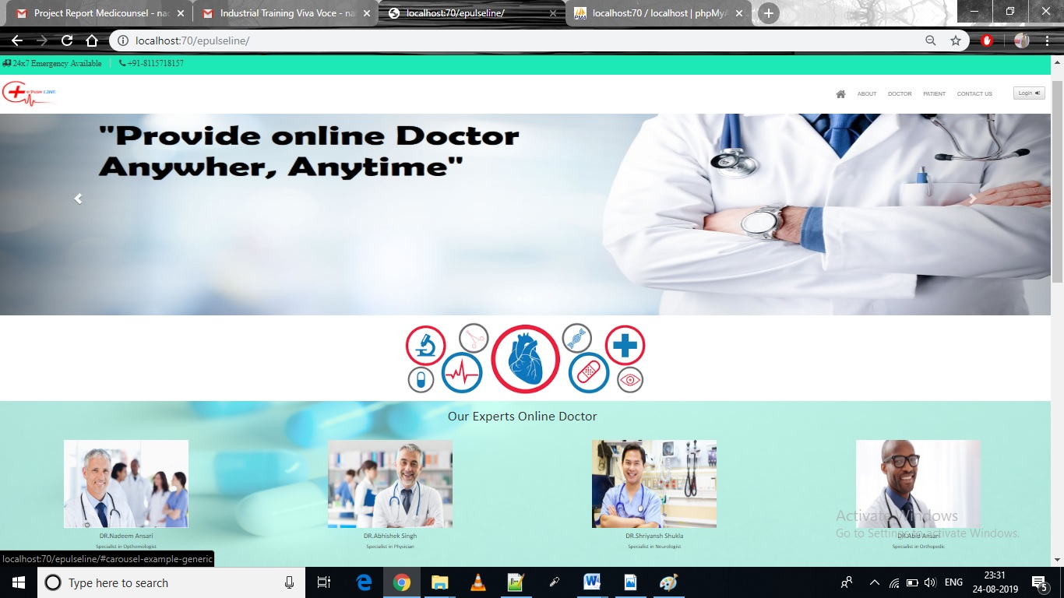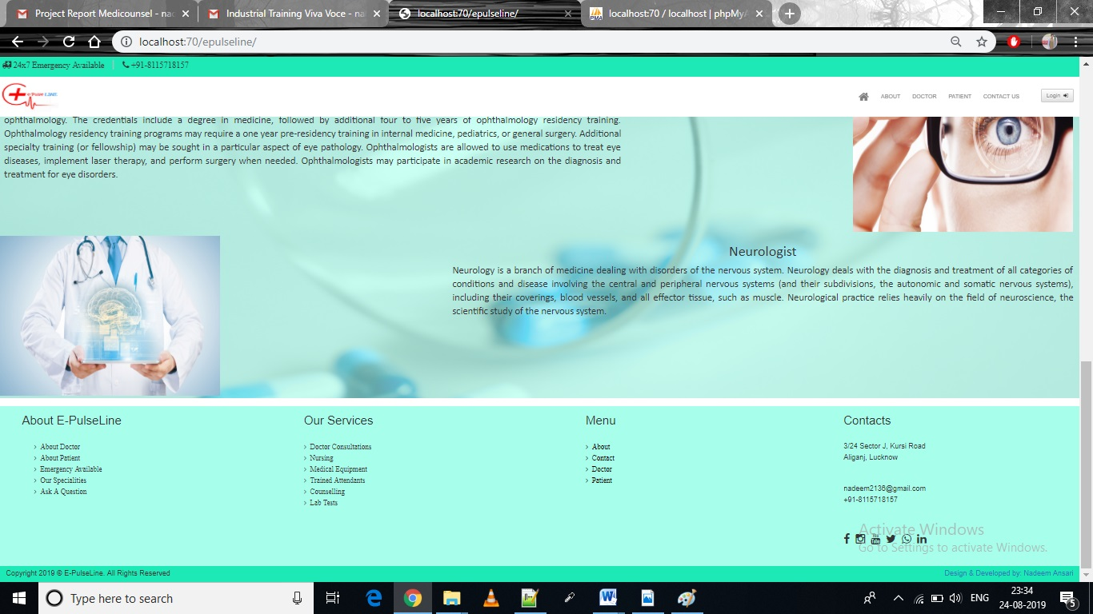

**Doctor Registration**

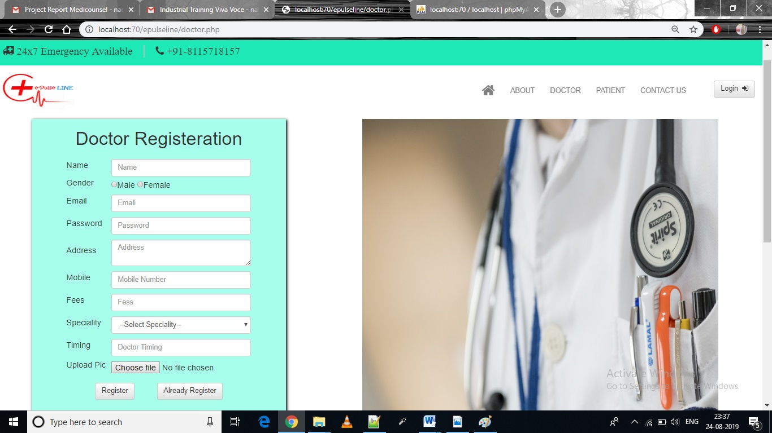

**Patient Registration**

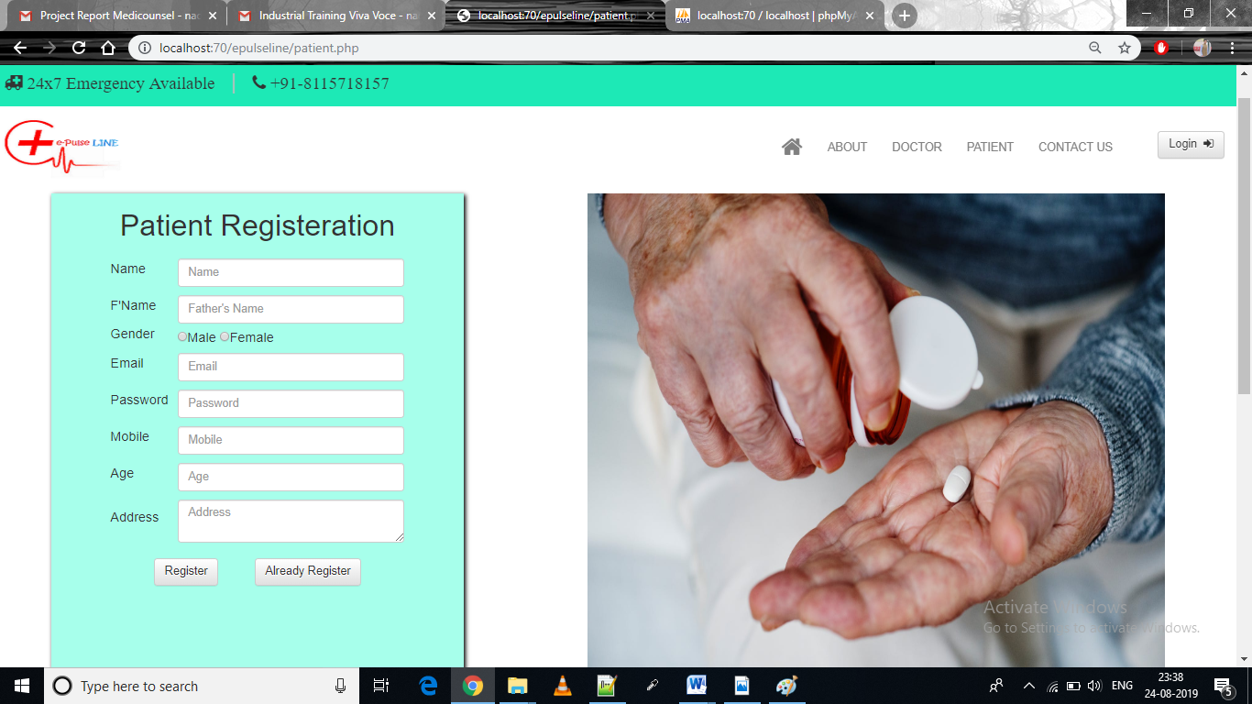

**Contactus**

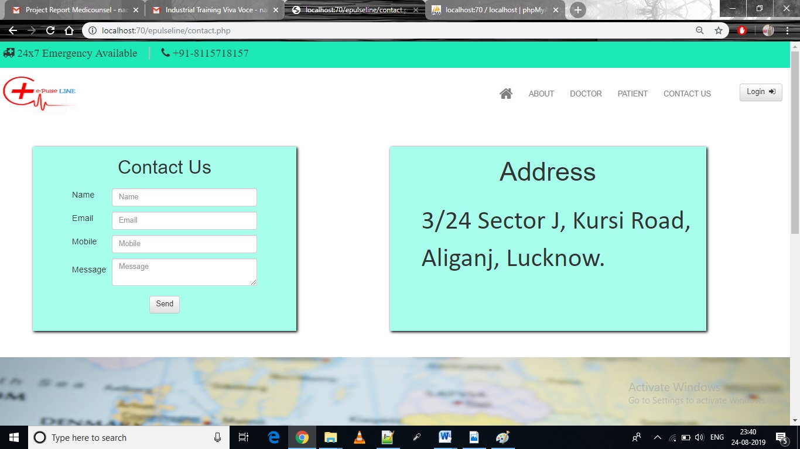

**Login**

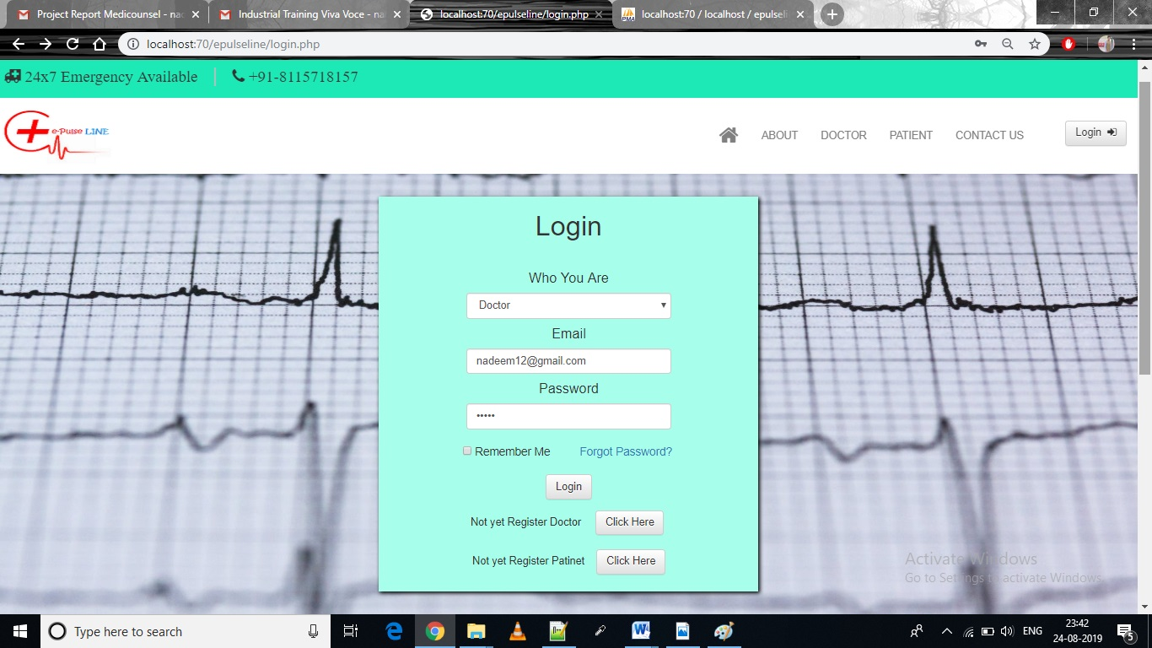

**Patient Profile**

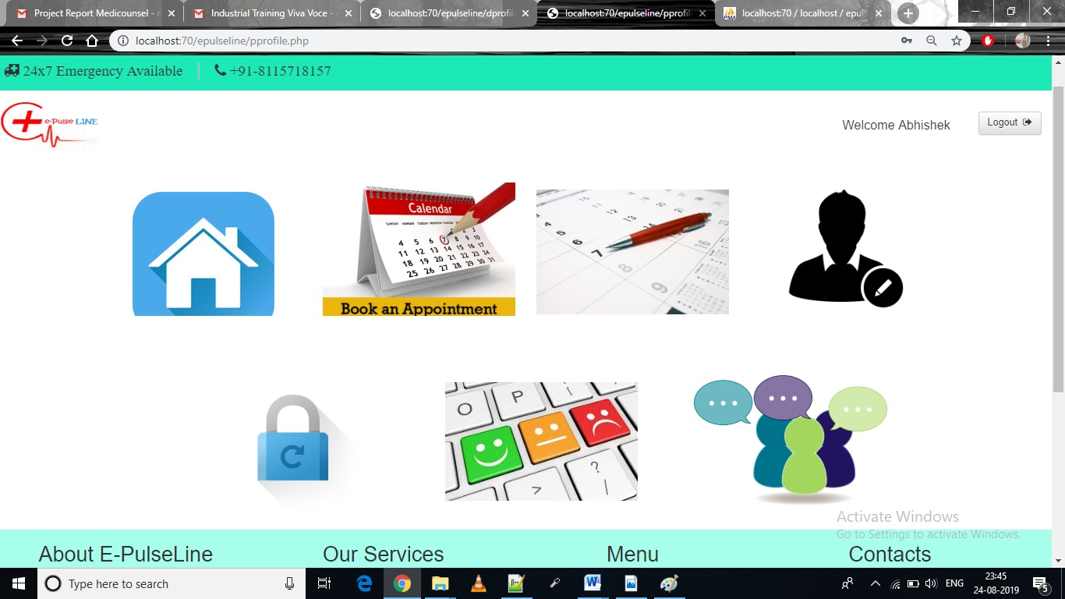

**Book Appointment**

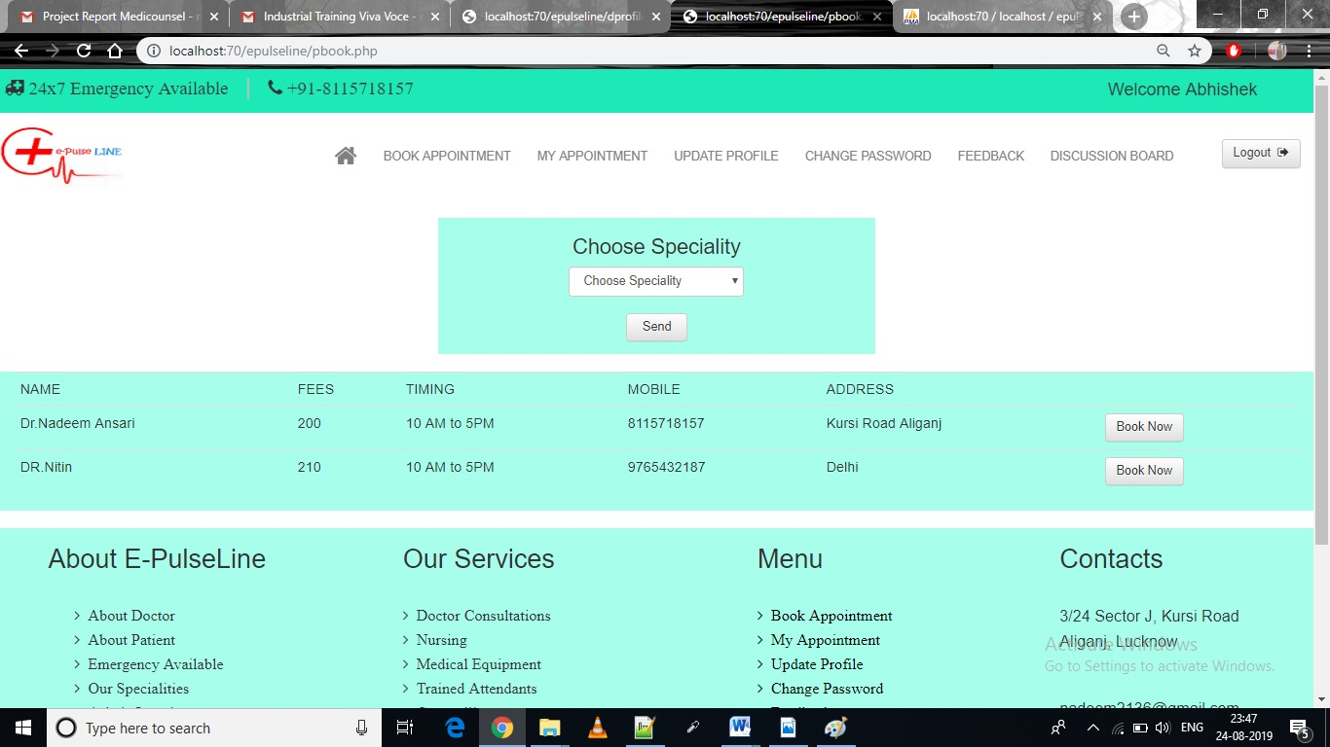

**Doctorprofile**

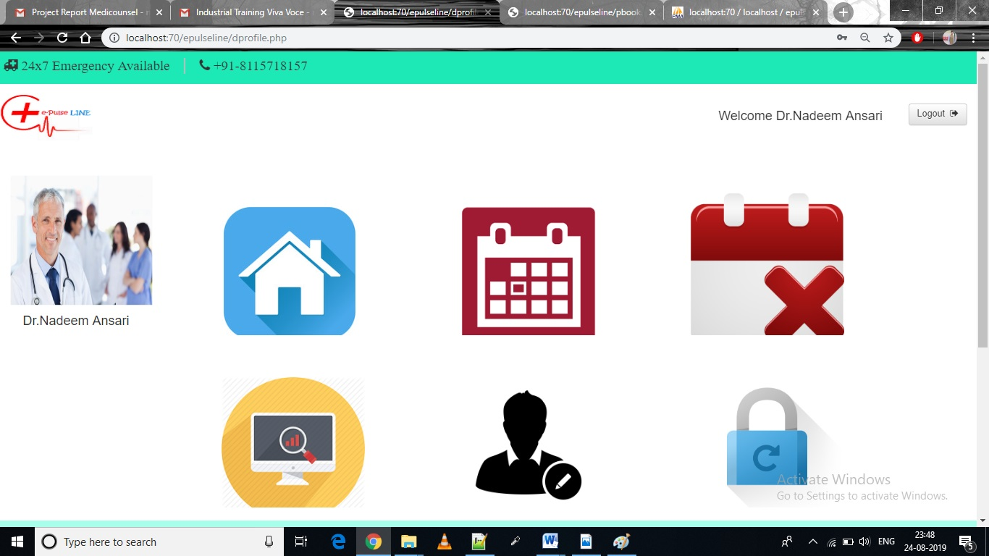

**View appointment**

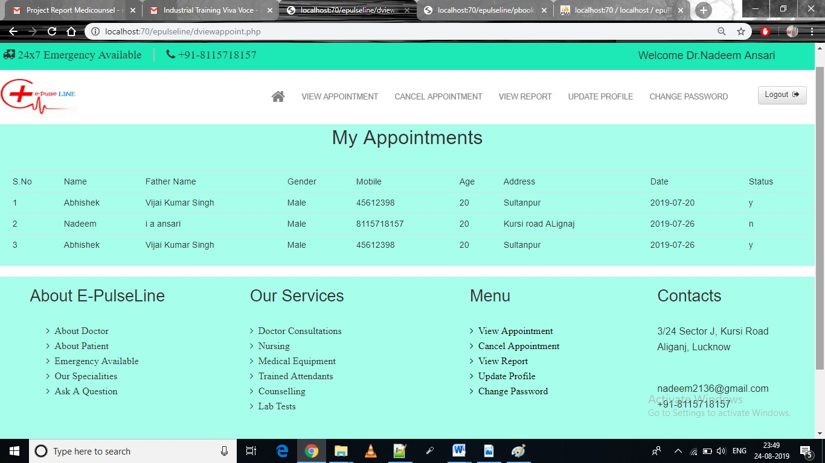

**AdminLogin**

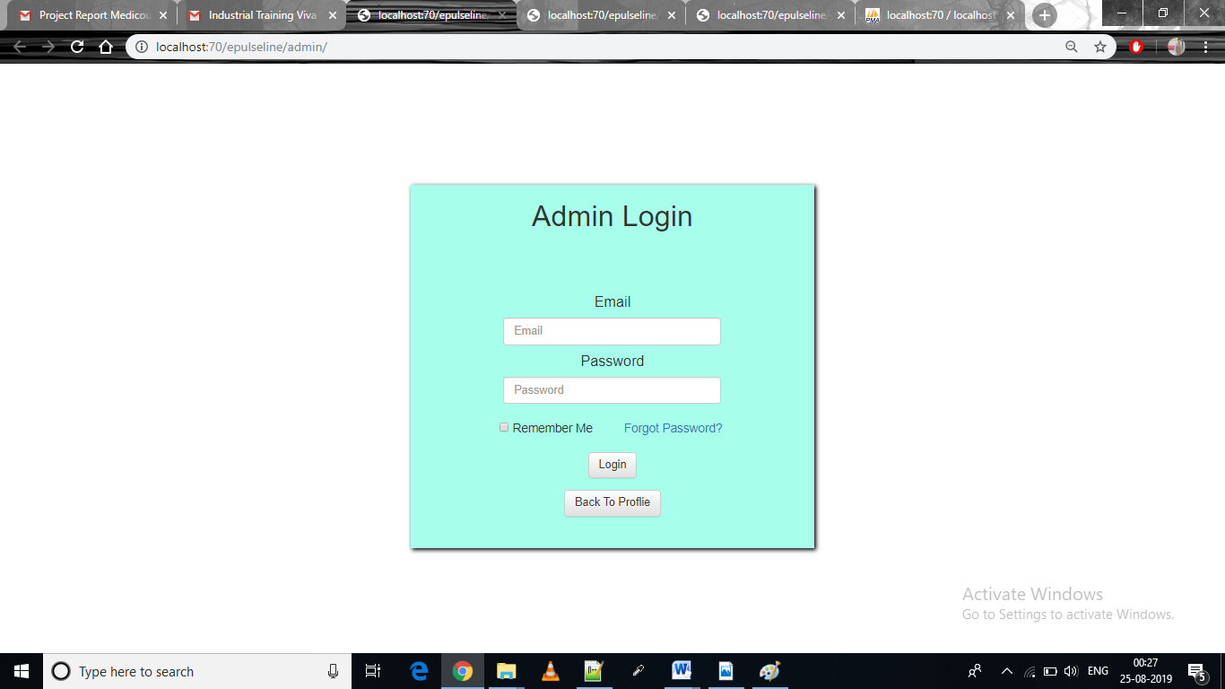

**Admin Home**

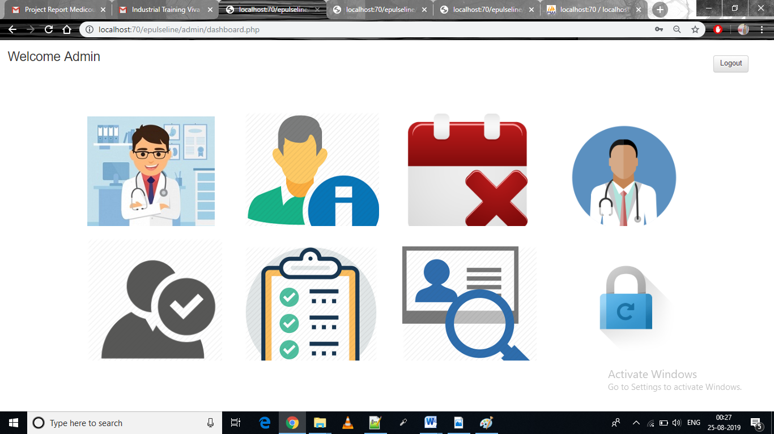

**View doctors**

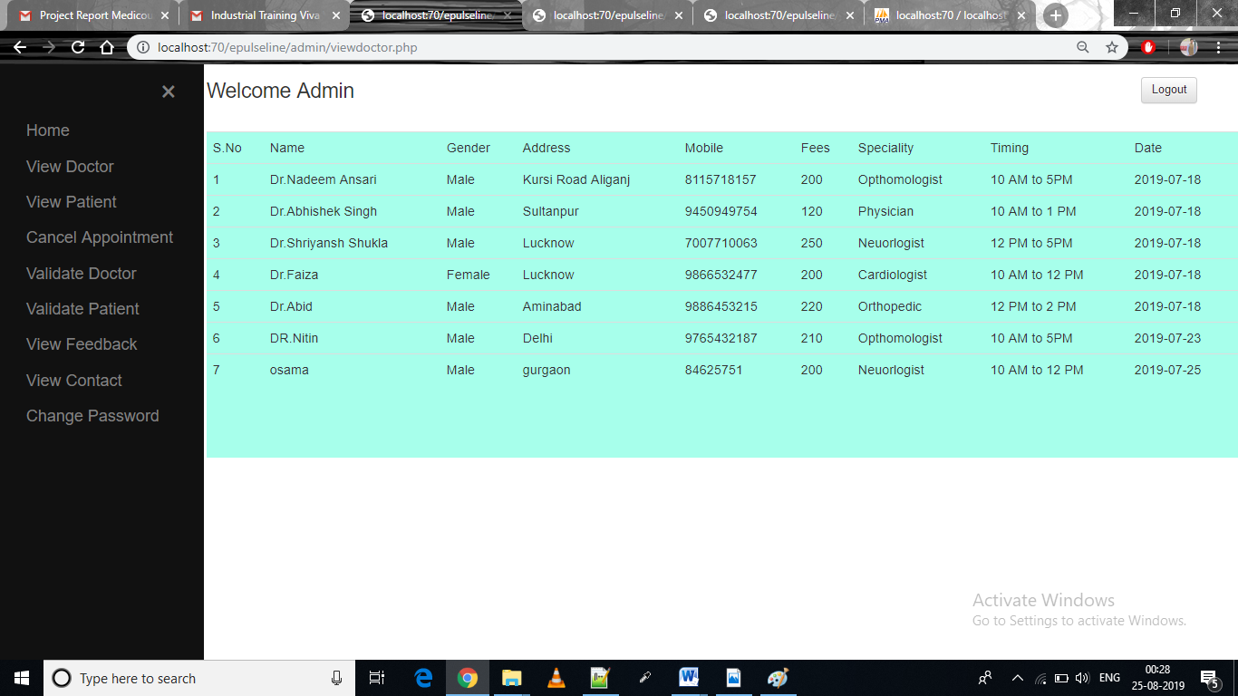

**View patient**

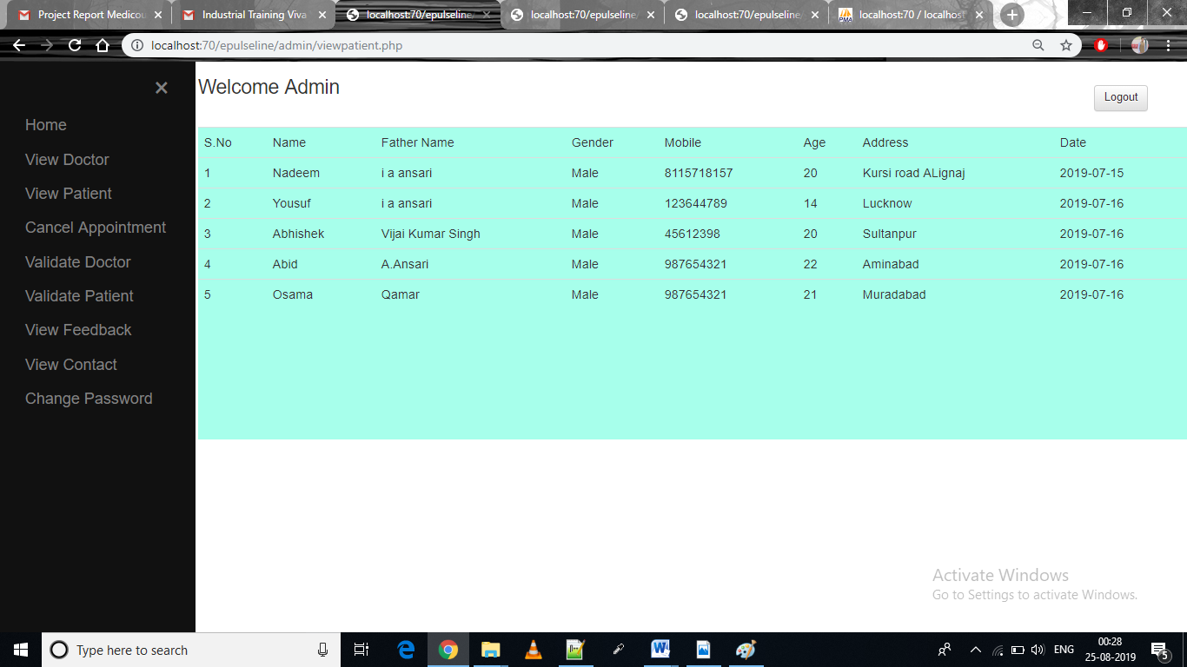

**Appointment**

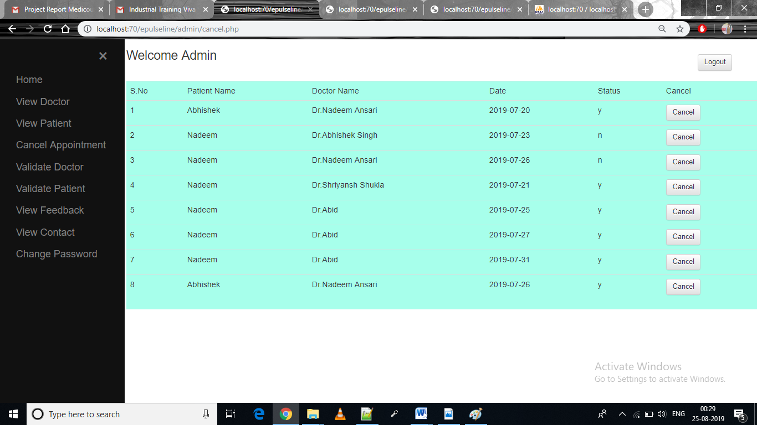

**Change Password**

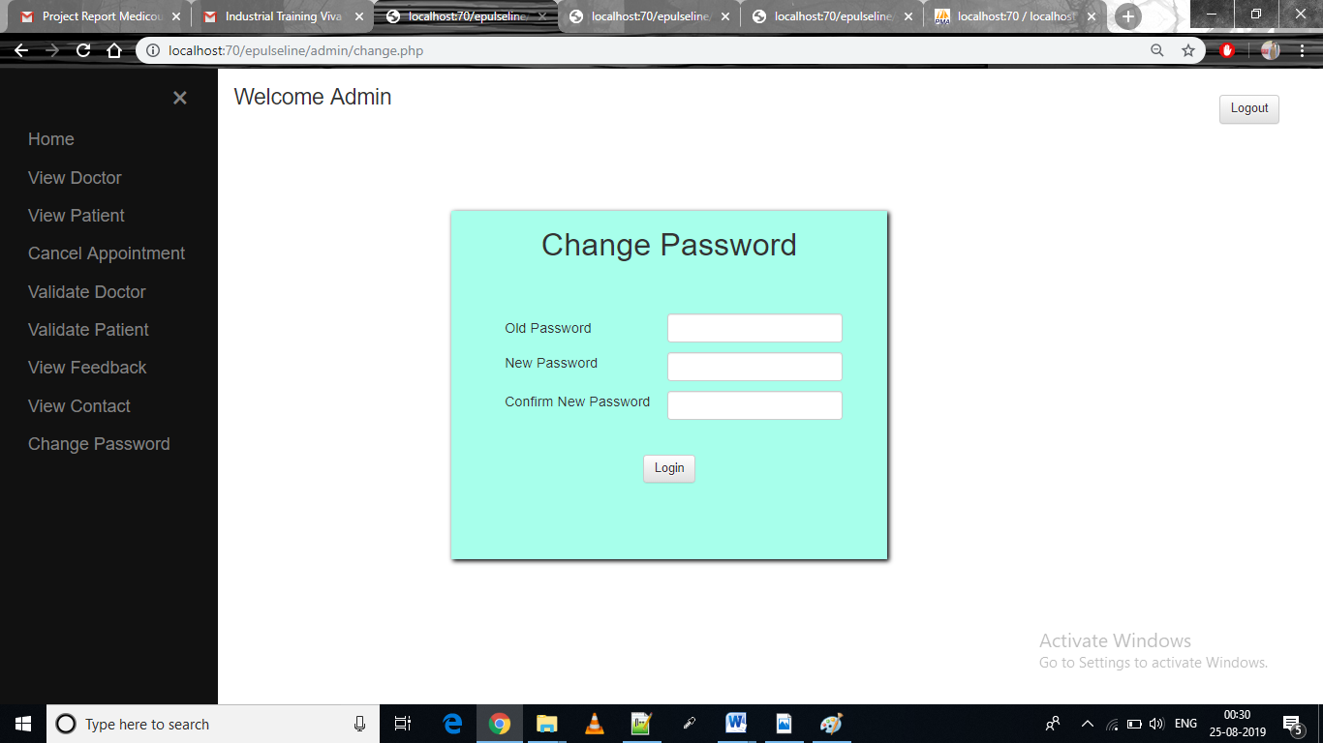

**DATABASE AND TABLES**

**LIST OF TABLES:**

* **Tbl_admin**
* **Tbl_answer**
* **Tbl_apponitment**
* **Tbl_contact**
* **Tbl_doc**
* **Tbl_patient**
* **Tbl_question**
* **Tbl_feedback**

1. **Tbl_admin**

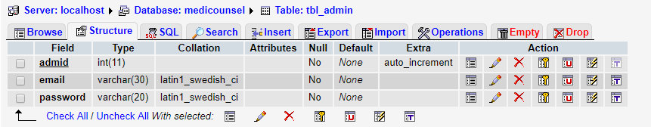

1. **tbl_answer**

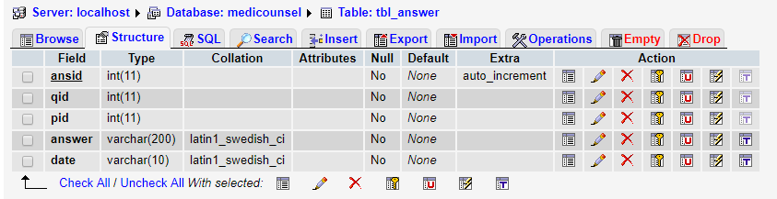

1. **Tbl_apponitment**

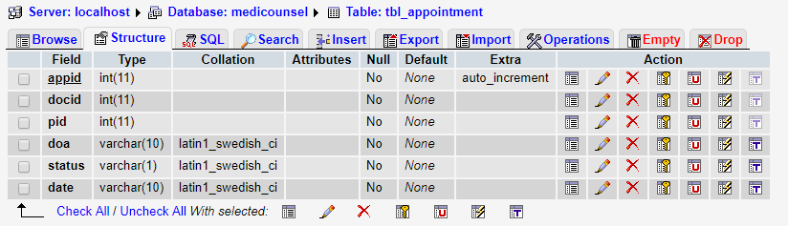

1. **Tbl_contact**

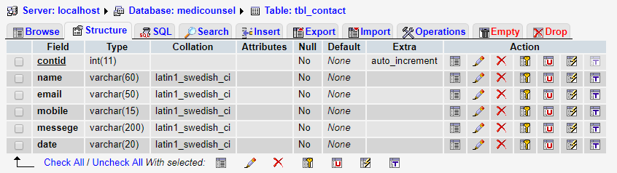

1. **Tbl_doc**

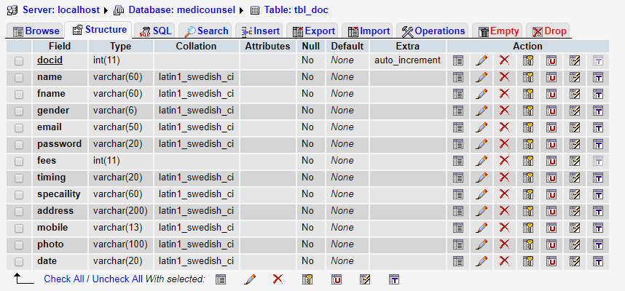

1. **Tbl_patient**

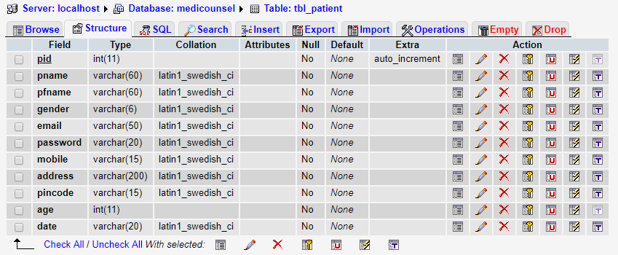

1. **Tbl_question**

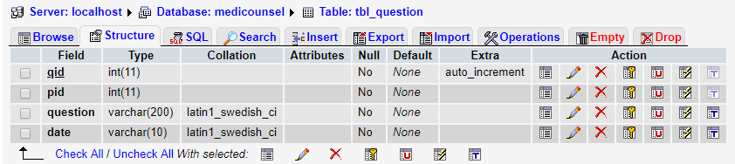

1. **Tbl_feedback**

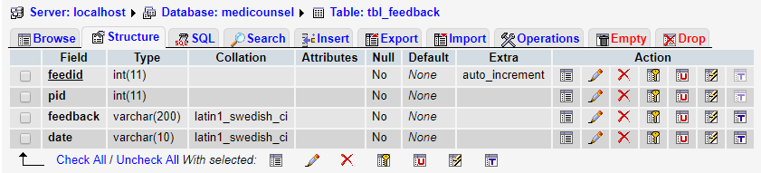

**TESTING**

Software testing is a critical element of software quality assurance and represent the ultimate review of specification design, coding, purpose of product testing is to verify and validate various work products via unit integrated unit, final product to ensure that they meet their requirements.

**UNIT TESTING:**

Unit testing is essentially for the verification of the code produced during the coding phase and the goal is test the internal logic of the module/program. Into the Generic code project, the unit testing is done during coding phase of data entry forms whether the functions are working properly or not. In this phase all the drivers are tested they are rightly connected or not.

All the tested modules are combined into subsystems, which are then tested. The goal is to see if the modules are properly integrated, and the emphasis being on the testing interfaces between the modules. The generic code integration testing is done mainly on table creation module and insertion module.

**INTEGRATION TESTING:**

Testing can be done in two ways:

1. Bottom up approach

2. Top down approach

**SYSTEM TESTING:**

Once the entire system has been built then it has to be tested against the ‘System Specification’ to check if it delivers the features required. It is still developer focused, although specialist developers known as system testers are normally employed to do it. In essence System Testing is not about checking the individual parts of the design, but checking the system as a whole. In effect it is one giant component. System testing can involve aunt of specialist types to see if all the functional and non-functional requirements these may include the following types of testing for the non-functional requirements.

**FUTURE SCOPE**

**Following modification or upgrades can be done in system.**

1. More than one company can be integrated through this software.
2. Web services can be used to know exact donation status of packets.
3. Client can check there donation delivery status online.

**CONCLUSION:**

During extended interviews with Patient sat 50 Clinic, we found different processes leading to the successful development and deployment of portals. The portal doesn’t have to be expensive. It should support multiple campus goals. It is clear that the functionality of a portal develops over time.

“**E-Pulse Line.com**” is not only a web portal; it is a live project of E-Pulse Line (USA). In future we will add more and more features on it. This portal can be used by any doctors Clinic or Hospitals.

**REFERENCES:**

* [www.w3schools.com/sql](http://www.w3schools.com/sql)
* [www.tutotialpoint.com](http://www.tutotialpoint.com)
* [www.youtube.com](http://www.youtube.com)
* [www.wikipedia.org](http://www.wikipedia.org)